Sinus infection (Sinusitis)

What are sinuses?
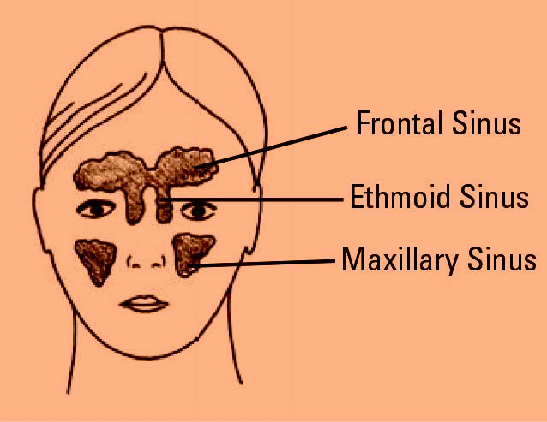Normal maxillary and frontal sinuses. (Sphenoid sinuses not shown).
There are four pairs of sinuses in the head that assist the control of temperature and humidity of the air reaching the lungs. Sinuses begin as pea-sized pouches in the newborn extending outward from the inside of the nose to the bones of the face and skull. They expand and grow throughout childhood and into young adulthood. Eventually they become air pockets or cavities that are lined with the same kind of lining that lines the nose. They are connected to the inside of the nose through smaller openings called ostia.
Normally the nose and sinuses produce a pint and a half of mucus secretions per day. These secretions pass backwards through the nose picking up dust particles, bacteria and other pollutants along the way. This mucus is swept into the back of the throat by millions of tiny hairlike structures called cilia, which line the nasal cavity. The mucus moves into the throat and is swallowed. Most people do not notice this mucus flow because it is a normal bodily function.

Types of sinusitis
Sinus infection occurs in two types. Acute sinusitis gives rise to severe symptoms but is usually short-lived. Acute sinusitis usually occurs following a cold. Typically a green-yellow nasal discharge occurs a week or more after the onset of the cold and this is associated with severe pain around the cheeks, eyes and/or forehead. This may be associated with swelling and a high fever along with toothache.
Chronic sinusitis is sinusitis that continues for many weeks. Chronic sinusitis may be caused by an acute sinus infection which fails to resolve or as a result of an underlying allergy affecting the lining membranes of the nose and sinuses. Common symptoms include nasal obstruction, headache, nasal discharge, low grade fever, reduced sense of smell, facial discomfort and halitosis.
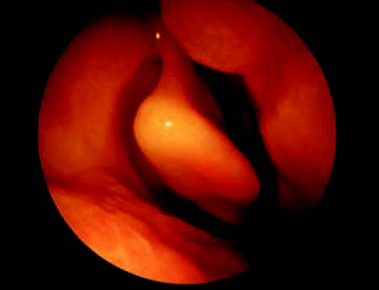  The view inside a ‘normal nose’. | 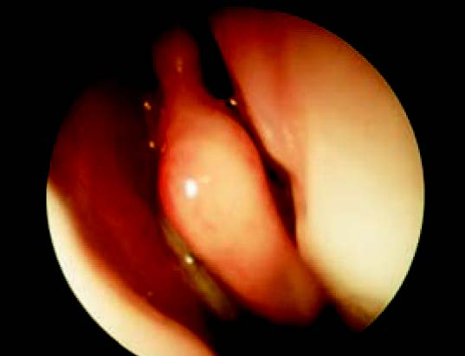  A patient with chronic sinusitis. The thick green mucus associated with a sinus infection can be seen draining into Frontal Sinus the nose.

What causes sinusitis?
It is worth noting that pain in the face may well be due to other causes such as tension headache, migraine, neuralgia and jaw dysfunction. The pain from sinusitis usually occurs as a result of blockage of the sinus opening. These blockages may be caused by infections, irritants, allergies or a structural abnormality.

Infections
Most adults will get colds and upper respiratory tract infections up to three times a year. Children get them more frequently. Bacterial infections often follow the common cold. When the mucus changes from clear to yellow or green it usually means a bacteria infection has developed. Both viral and bacterial infections cause swelling of the tissues inside the nose and thickening of the normal mucus. This slows down or even stops proper sinus drainage and infection in the sinus may ensue.

Irritants
Air pollution, smoke and chemical irritants, for example some sprays containing pesticides, disinfectants and household detergents, may cause swelling and blockage of the lining of the nose causing a narrowing of the drainage opening from the sinuses. This can once again lead to impairment of sinus drainage and consequent infection.

Allergies
Allergies can cause inflammation inside the nose. Common symptoms of an allergic reaction include nasal stuffiness, runny nose, sneezing and itchy watery eyes. Chronic sinusitis is sometimes associated with asthma. Allergies are responsible for asthma in some patients and may also cause nasal stuffiness making the asthma more difficult to control.

Structural problems
Occasionally structural problems within the nasal cavity can cause a narrowing. Some of these can be caused as a result of trauma while others may develop during the growth period. Occasionally the structural narrowing can be so severe that mucus builds up behind these areas of blockage giving rise to sinus infection.

Diagnosis and treatment of sinusitis
Acute sinusitis is usually treated with antibiotics and medication to reduce the swelling of the nasal lining e.g. decongestants. Chronic sinusitis may need long term treatment. Medical treatment options include antibiotics, decongestants and other treatments to reduce the swelling of the lining such as nasal steroid sprays. Antihistamines will have a place in patients who have an underlying allergy. In the vast majority of cases sinusitis can be managed effectively with medical treatment.
Occasionally symptoms will persist despite ongoing use of medicines in which case surgery may be necessary. The diagnosis of sinusitis by a specialist will involve the use of a nasal endoscope which the doctor can use to examine the nasal lining and the sinus openings.
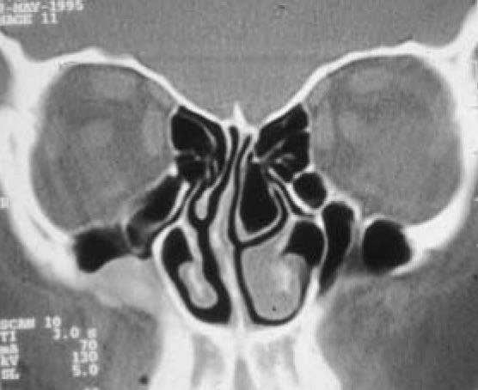CT scan of normal nose and sinuses.

Sinus surgery
Surgery is normally only considered if medical treatment fails. When surgery is needed the ENT specialist can choose from a number of different options depending on the severity of the sinus disease. Most sinus operations are performed without an external incision. Most surgeons will ask for a scan of the sinuses to assist with the planning of the operation. If you would like to have a second opinion about the treatment, you can ask your specialist. He or she will not mind arranging this for you. You may wish to ask your own GP to arrange a second opinion with another specialist.

by Matthew Yung
Disclaimer: This publication is designed for the information of patients. Whilst every effort has been made to ensure accuracy, the information contained may not be comprehensive and patients should not act upon it without seeking professional advice.
The Royal College of Surgeons
38-43 Lincoln's Inn Fields,
London WC2A 3PE
Tel: 0207 404 8373
Email: entuk@entuk.org
Registered Charity no: 1125524
Registered VAT no: 215668302
Privacy PolicyTermsCookie PolicyLogin
Designed & Developed by LightMedia

