Sinus surgery for chronic rhinosinusitis without nasal polyps - NEW

ABOUT THE CONDITION

What are sinuses?
Sinuses are air-filled spaces in the bones of the face and head. They are connected to the inside of the nose through small openings.
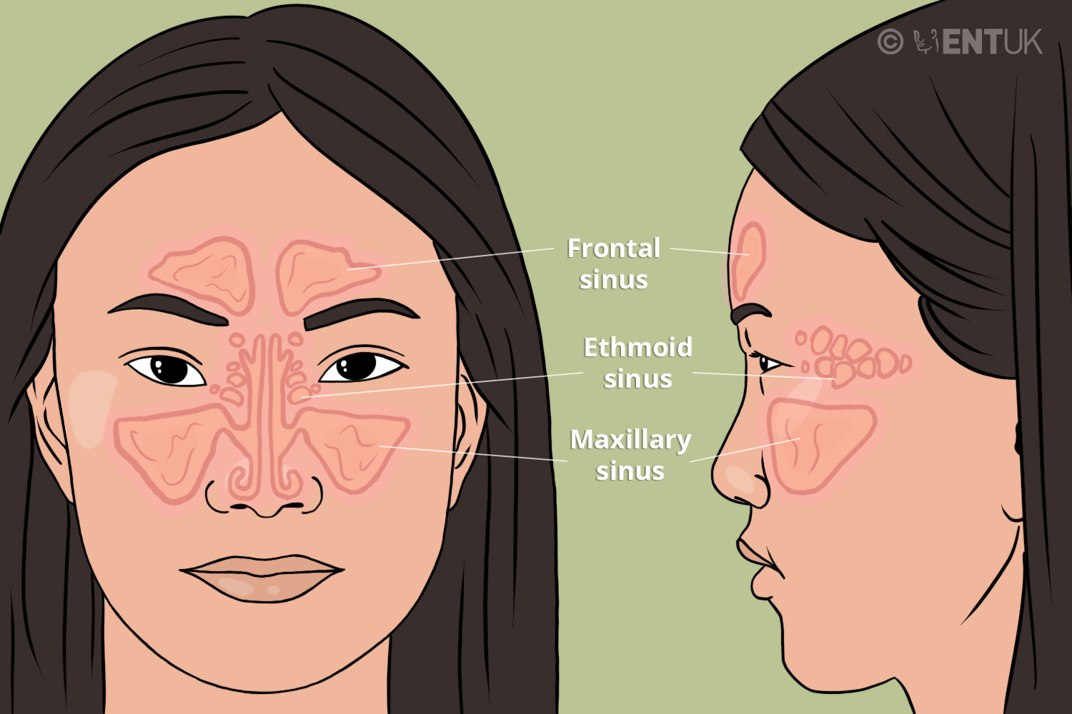
Figure 1. Position of the nasal sinuses.

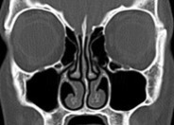
Figure 2: CT scan showing normal sinuses (the areas in black).

What is chronic rhinosinusitis?
Rhinosinusitis is swelling (inflammation) in the lining of the nose and sinuses. To be diagnosed with rhinosinusitis you must have either nasal blockage, nasal discharge, or both. You may also have a poor sense of smell or pain in your face. Children may have a cough. When you have these symptoms for more than 12 weeks, it is called Chronic rhinosinusitis (CRS). Symptoms that only last for a few weeks are usually caused by a virus, most often the common cold.
There are two main types of CRS with and without nasal polyps. Nasal polyps are little round growths that develop inside the nose – see the ENT UK booklet "Sinus surgery for chronic rhinosinusitis with nasal polyps".
In CRS without nasal polyps, the lining of your nose may be swollen, and the lining may be covered in discoloured mucus as shown in Figure 3 (right).
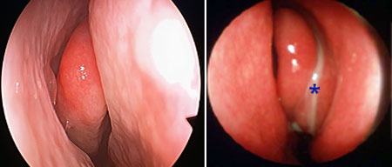
Figure 3: (left) healthy nasal lining; (right) swollen nasal lining. The entrance into the sinus is blocked by the swollen lining and mucus*.

What causes CRS?
CRS may be the result of repeated nasal infection (colds). In a small number of cases, the nose overreacts to the presence of fungal spores that are present in the air. Some patients have allergic rhinitis caused by an allergy to something in their environment. In most patients there is no identifiable trigger.

How can CRS affect me?
Your nose may feel blocked or congested. You may see discoloured mucus when you blow your nose. Sometimes it feels like mucus is trickling down the back of the nose. You may have a weak sense of smell, or no sense of smell at all. You may have a feeling of pressure or pain in your face.

How is CRS treated?
CRS is a chronic (long-term) disease. This means that the aim of treatment, even if you have surgery, is to control your symptoms. This will need ongoing medication, which you will have to take every day. If your condition is under control, you may have no symptoms, but they may return if you stop taking the medication.
Long-term medication includes steroid nasal sprays and saline (salt water) nasal rinses. Sometimes, long-term antibiotics or short courses of steroid tablets are needed. An operation called endoscopic sinus surgery may be recommended in about one out of three CRS patients who go to an ENT clinic.
Nasal steroids shrink the swollen lining and may completely treat your nasal symptoms. Steroid sprays and drops work well in the nose and have fewer side effects than steroid tablets. Some patients are also given a course of steroid tablets if their symptoms are severe, but the effect of these tablets may be temporary.
CRS is not caused by a chronic bacterial infection, and antibiotics are not helpful for most patients. However, some antibiotics can also improve inflammation. Some patients with CRS without nasal polyps may need a long-term course of antibiotics (taken for more than four weeks), which helps bring the swelling down.
The treatments above will control most patients’ symptoms well.

ABOUT THE PROCEDURE

Why has endoscopic sinus surgery been recommended to me?
Surgery is recommended in CRS when your symptoms are still not under control, despite using nasal steroid sprays and saline rinses (and perhaps some of the other treatments described above).
The main aim of surgery is to improve the long-term control of your symptoms when treatment with medication has not been completely effective. The operation will not cure you of CRS or mean you no longer need to take regular medication.
Opening the sinuses with surgery will improve the symptoms of nasal blockage and discharge. It will allow the nasal sprays and rinses to reach the parts of your nose and sinuses that were blocked. Your sense of smell may not return after the operation.

What does the operation involve?
Endoscopic sinus surgery (ESS) is usually performed while you are asleep under a general anaesthetic. A CT scan of the nose and sinuses is usually carried out to help your surgeon plan what type of operation you will need.
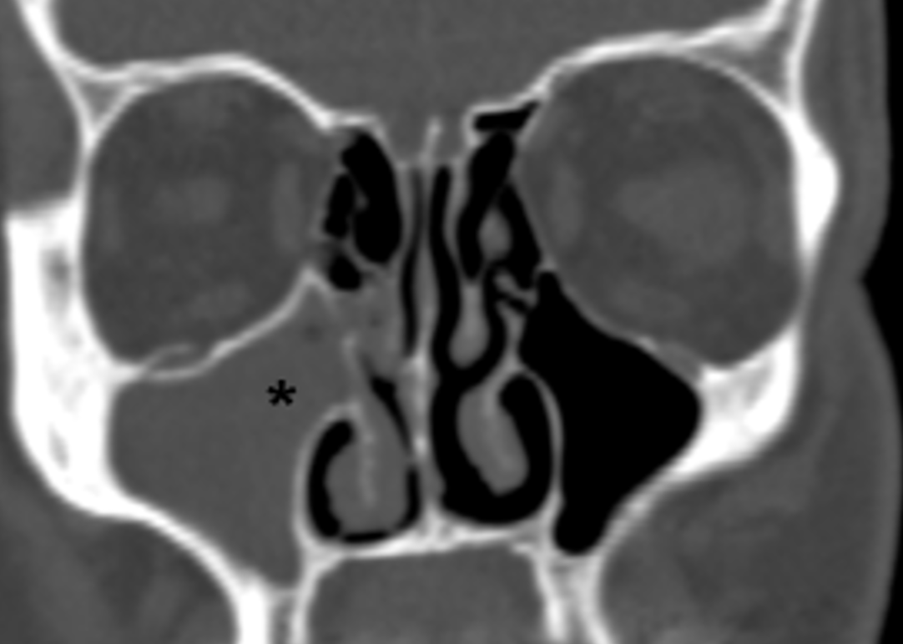
Figure 4: CT scan showing sinus filled with mucus (grey space on left) and blockage of the entrance into the cheek sinus.

A long, thin tube called an endoscope is passed into your nostrils to perform the operation. The endoscope is connected to a camera, which allows the surgeon to see the inside of your nose and sinuses on a monitor screen.
The swollen nasal and sinus lining and bone are cut away to unblock and widen the natural openings into your sinuses. Trapped mucus and pus are drained from the sinuses. The amount of surgery performed will depend on how swollen the lining of your nose and sinuses is, and whether cutting away more tissue will increase the benefit without increasing the risks.

What are the alternatives to surgery?
Before considering surgery, your ENT specialist will have treated you with saltwater douches or spray, and with steroid drops or sprays. Steroids sprays and drops shrink the swollen lining (including any polyps) and may completely treat your nasal symptoms. Steroid sprays and drops work well in the nose and have fewer side effects than steroid tablets. Some patients are also given a course of steroid tablets if their symptoms are severe. In certain cases, they may be offered a longterm course of antibiotics to reduce swelling in the sinuses.
Most patients respond to these medications well. If you have only mild symptoms, an operation may not be the best way to help you. This is also true if you have other conditions that make it risky to have surgery or a general anaesthetic,
Most patients will be advised by their consultant to continue the medications as described above. The swollen lining may shrink completely in response to treatment, but if polyps are present, the polyps tend to return if steroids are stopped, even after an operation. Steroid tablets and strong steroid drops have side effects on the rest of the body and cannot be taken for long periods of time. Your ENT specialist can advise on how long the treatment should last. Steroid sprays and rinses are not usually absorbed by the rest of the body and can therefore be taken for long periods of time.

Are there any alternative operations to endoscopic surgery?
Most sinus surgery is performed through endoscopes inserted into the nostril, as described above. But sometimes a surgeon needs to make cuts on the nose, face and inside the mouth to reach the inside of the nose and sinuses. Cuts take longer to heal and can become infected. Your face and possibly the inside of the mouth become swollen after open surgery. Open surgery is usually only advised when the problem in the sinuses cannot be reached with an endoscope.

What if I decide not to have surgery?
Many patients with CRS use medication to control their symptoms and do not need surgery. You may have decided that the risks of surgery are greater than the benefits. You may continue to have symptoms and should continue using saline rinses as well as steroid sprays.
Sinusitis is not usually serious, but the symptoms can be unpleasant, interfere with your daily life and make you less productive. CRS goes hand in hand with late-onset asthma, especially when not well controlled. In rare cases, sinusitis complications can happen, such as a serious infection that spreads to the area around the eye (periorbital cellulitis) or the brain and forehead.

What if I decide not to have any treatment at all (including saline rinses and steroids)?
In many cases, your symptoms may continue to be uncontrolled, or may slowly get worse. This may make you feel tired and can make complications more likely. It can also make it more likely that you will develop asthma. You may continue to have problems breathing through your nose and your sense of smell will still be weak.

AFTER THE PROCEDURE

What happens after the operation?
After the operation, you will be taken to the recovery area. When your anaesthetic has worn off, you will be taken back to the day surgery unit if your surgery is planned as a day case, or to the ward if you are staying overnight. If there is a complication, you might need to stay in hospital for longer.
You may wake up with nasal packing inside your nose. The most usual type of packing used will dissolve on its own with time. Sometimes packing is used that has to be removed a few hours after surgery.

Nasal blockage
Your nose may feel blocked for seven to ten days after your operation. This will gradually improve.

ABOUT THE RISKS

Are there any complications to this operation?
The complications and risks of any surgery are grouped into the following categories.
Most endoscopic sinus surgery takes place without complications.

Nosebleeds
Nosebleeds are very common, and most are minor (some spotting of blood on a tissue or in your mucus) and settle down quickly. Do not blow your nose for two days after you get home, and then start off by blowing very gently. Take it easy at home. Do not do anything too energetic for the first few days in case this makes your nose bleed. About one out of 20 people experience a bad nosebleed after surgery.

Infection
The operation site may get infected. If this happens, you may need antibiotics. The best ways to stop infection happening are to use saline rinses and cut down contact with others as much as possible for two weeks after surgery.

Adhesions
Sometimes the tissues inside the nose may stick together as they heal, forming bridges of scar tissue called adhesions. The scar tissue may not require any treatment, but the surgeon may cut the tissue in clinic or during another operation if it blocks the nose or stops the sinuses draining.
Endoscopic sinus surgery has some more serious possible complications, which could affect your day-to-day life. These complications can affect the eye and the areas around it, or your brain and skull base. However, these are rare. The CT scans in figures 2 and 4 show how close the nasal sinuses are to the eye sockets and base of the brain.

A break in the bone between the nose and the eye socket
The sheet of bone between the nose and eye is paper-thin and can be damaged during surgery. Chronic rhinosinusitis can also wear the bone away as it develops. The area around the eye may become bruised or swollen if the bone is cracked. This is uncommon.

A watery eye
The tear duct pathway runs in front of the cheek (maxillary) sinus. This may be damaged during the surgery and can lead to a watery eye (known as epiphora). This is uncommon (less thanone out of 100 cases).

Double vision
Fat surrounding the eyeball can escape into the nose through a crack in the thin bone between the eye socket and the nose. The eye muscle can also be damaged. These can cause double vision until they heal, although this is very rare.

Bleeding into the eye socket
In roughly one out of 500 cases (0.2%), a small blood vessel in the nose can bleed into the eye socket. This makes the eye bulge forward. This can cause loss of vision in that eye if not treated quickly, as the blood puts pressure on the optic nerve (the nerve of vision). The surgeon can make a cut on the outer corner of the eye to relieve this pressure or may do this with an endoscope. In the long term, the scars from these cuts heal well. Direct damage to the optic nerve is possible, although loss of vision from sinus surgery is extremely rare.

Leakage of cerebrospinal fluid (CSF)
If there is damage to the bone between the brain and the nose, a type of fluid cushioning the brain (called cerebrospinal fluid, or CSF) can leak into the nose. This is rare and happens in (about one out of 1,000 cases). Sometimes the thin bone can be worn away as the disease develops, revealing the leak once the polyps or tissue are removed.
If a leak is noticed during surgery, this can be repaired using either fat and tissue or manmade materials. If this happens, you will need antibiotics in your vein and will be in hospital for more than one day. To help the area heal without another leak, you may need to avoid some physical positions and any activity that would make you strain. We may give you medication to soften your bowel movements if needed. Your surgeon will explain the aftercare to you in more detail if you have a cerebrospinal fluid leak, although these are very rare.

Meningitis
A cerebrospinal fluid leak can lead to meningitis. This is swelling of the lining of the brain. Antibiotics will be needed if this happens.

Complications of general anaesthetic
The operation is usually performed under a general anaesthetic. Complications include blood clots in the legs (known as deep vein thrombosis) or lungs (known as pulmonary embolism), as well as heart attack, chest infection, stroke, and death. The pre-assessment team and anaesthetist will explain to you what happens during a general anaesthetic and any risks that may affect you. The document linked explains the common events and risks of a general anaesthetic.

AFTER THE PROCEDURE

When can I go home?
Most operations are performed as a day case. This means that you may be able to go home on the same day as your operation, a couple of hours after the general anaesthetic has worn off, as long as you feel well enough. You will need to be looked after by a responsible adult for 24 hours after a general anaesthetic.

Do I need to take medication after the operation?
Yes. You will need to keep using a nasal steroid (sprays or drops) and saline rinses after the operation. You may need other medication, such as a short course of steroid tablets. The operation is more successful when patients keep using a steroid spray and saline rinses.

How successful is the operation?
Although the condition is chronic and cannot be cured, the operation is often very successful, particularly at easing the feeling of a blocked nose. Overall, nine out of ten patients are satisfied with the outcome of the operation up to five years after endoscopic sinus surgery. Continuing to take the medication and saline rinses after the operation plays an important part in how successful your surgery will be.
The condition may come back from time to time, but this can usually be controlled with medication. Roughly one in ten patients may need another sinus operation within five to ten years. Using a steroid spray daily and using saline rinses or sprays regularly makes it less likely you will need another operation. Smoking seems to make the need for further surgery more likely.
Unfortunately, it is difficult to know if your sense of smell will return. Some patients experience partial improvement, some have temporary improvement, and some have no improvement at all.

How long will I be off work?
We recommend up to two weeks off work, but some people feel well enough to start work earlier.

Can I exercise?
Heavy lifting, running, exercise classes and heavy housework or gardening should be avoided for two weeks after surgery as these activities may make your nose bleed.

Can I fly?
We recommend that you avoid flying for two weeks after the operation.

Can I smoke?
Avoid smoky atmospheres, as cigarette smoke will irritate the inside of the nose and may slow down healing. We advise not smoking before or after your surgery.

When will I be followed up?
Your team will inform you when you will be seen in the clinic for a follow-up appointment.

QUICK FACTS
- FESS surgery is common
- Nosebleeds are common after surgery
- Surgery is to help you breathe, improve symptoms, allow medications to get into the nose easier and reduce complications of untreated CRS.
- Your sense of smell may not return after the operation
- Using nasal steroid medication daily and saline rinses after ESS will improve the success of your operation
- Serious but rare complications include loss of vision, CSF leak and meningitis
- Avoid flying, visiting the gym or doing any heavy housework for two weeks

Authors: Carl Philpott, May Yaneza, Thomas Jacques

Disclaimer: This publication is designed for the information of patients. Whilst every effort has been made to ensure accuracy, the information contained may not be comprehensive and patients should not act upon it without seeking professional advice.
The Royal College of Surgeons
38-43 Lincoln's Inn Fields,
London WC2A 3PE
Tel: 0207 404 8373
Email: entuk@entuk.org
Registered Charity no: 1125524
Registered VAT no: 215668302
Privacy PolicyTermsCookie PolicyLogin
Designed & Developed by LightMedia

